The effect of host plant species on wing morphology and symmetry in monarch butterflies (*Danaus plexippus*)

**Ducat, Caitlin E**.; Steele, Christen H.; Maldonado, Brittany R.; and Caz M. Taylor

**I. Introduction**

Morphological analysis, a cornerstone of evolutionary theory, has been used to define evolutionary relationships, classify organisms, and evaluate the functional relationship between morphology and ecology (Ricklefs & Miles 1994). Literature surrounding morphological analysis concerns the ways that an organism’s genotype and environmental conditions contribute to the expression of a phenotype and the variations of that phenotype that can occur (Berns 2014). When an environmental factor, such as climate or diet, strongly influences a phenotypic trait, the trait is said to demonstrate adaptive phenotypic plasticity (Berns 2014, Via & Lande 1985). Species that exhibit more plasticity can theoretically occupy a wider variety of niches and adapt more readily to changes in environmental factors that may influence individual fitness as well as population fitness, more holistically.

Much of the research on the links between morphological traits, adaptive plasticity, and fitness components has been observed in insects, specifically in the way variations in flight apparatus correlate with flight performance. In 2002, Berwaerts and colleagues demonstrated that morphological traits such as total body mass, thorax mass, forewing area, forewing length, wing loading, aspect ratio, and center of forewing area were positively correlated with maximal acceleration capacity in the speckled butterfly, *Pararge aegeria*, directly linking morphological traits to flight fitness.

The eastern migratory monarch butterfly (*Danaus plexippus)* provides a unique opportunity to observe the correlation between morphology and flight fitness in the context of long-distance migration. Wing shape and symmetry and the factors that affect them are of great interest because of the monarchs’ long trek. The species is well known for its annual transcontinental migration from southern Canada to Michoacán, Mexico, where individuals overwinter in reproductive diapause. Understanding environmental influences on the phenotype, specifically wing shape, of monarch butterflies could hold many implications for evaluation of monarch fitness and conservation, and provide insight into the recently noted changes in migratory behavior of the species.

Howard et al. (2010) documented a subpopulation of monarchs that are dropping out of migration, opting instead to breed year round along the Gulf coast. The majority of these migratory “drop-outs” are feeding and breeding on a species of non-native milkweed called Mexican or tropical milkweed (*Asclepias curassavica*), which is ubiquitous in urban areas, easily maintained, and does not senesce in the winter like its native counterparts (Satterfield et al. 2015). This shift in milkweed phenology is thought to be a possible cue for monarchs to break reproductive diapause and end migratory behavior, “trapping” them in habitats along the gulf (Batalden & Oberhauser 2015).

The goal of this study is to compare the impacts of the non-native *A. curassavica* vs. a native species, swamp milkweed (*Asclepias incarnata*), on the wing morphology and symmetry of monarch butterflies. Berns (2014) suggested that monarch butterfly forewing size and shape are influenced by diet and cardenolide concentration of host plants. *A. curassavica* contains significantly higher levels of toxic cardenolides than many native species. Cardenolides are a toxic secondary steroid compound known to cause cardiac arrest in some animals in high concentrations (Agrawal et al. 2012). They have been linked to lower survival rates in monarch larvae, but increased longevity in adult monarchs infected with the protozoan parasite OE (*Ophryocystis elektroschirrha*)(De Roode et al. 2008, Gowler et al. 2015). *A. curassavica* is generally easier to grow and maintain than many other milkweed species, and its year-round availability permits year-round breeding. Understanding the effects of an *A. curassavica* diet on wing morphology could provide some insight into the mechanisms underlying migratory dropout and aid in conservation measures for monarchs and their migration.

We hypothesize that wing shape and symmetry will vary between adult monarchs reared on *A. incarnata* and *A. curassavica* due to the differences in cardenolide concentrations of the milkweed species. If *A. curassavica* is partially responsible for the increase in sedentary behavior among eastern migratory monarchs as Batalden and Oberhauser (2015) suggest, we predict that individual monarchs reared on *A. curassavica* will exhibit morphological traits consistent with lower flight success (shorter, broader forewings and low aspect ratio), and possibly higher reproductive success to support year-round breeding. Additionally, we anticipate different responses to diet treatment between the two sexes. Monarchs are sexually dimorphic, with males and females differing in size and wing shape due to differences in life histories and reproductive strategies. Lindsey & Altizer (2009) suggest that because of the trade off in energy allocation between reproduction and costly immune defenses, infections patterns should differ between male and females. We expect this to be the case as well with dimorphic responses to the milkweed diet treatment.

**II. Materials and Methods**

*Butterfly Rearing*

Prior to the start of the experiment, we captured one male and two female adult monarch butterflies from the local population in uptown New Orleans, Louisiana in June of 2018. We bred two family lines from this initial generation that we used for this experiment. We harvested the eggs laid by the females and bleached them to remove any parasite contamination prior to rearing.

We raised ten monarchs from egg on a diet of Mexican (tropical) milkweed (*A. curassavica)* and ten on native swamp milkweed (*A. incarnata)* inside of a growth chamber kept at an average daily temperature of approximately 85°F, in which they received sixteen hours of light per day. Upon hatching, the larvae were placed in 4.7L containers with metal-screened lids, which held two caterpillars at once until the individuals reached the third instar stage. Once the caterpillars reached the fourth instar stage, we transferred them into individual containers until pupation.

For this experiment, we fed the caterpillars *ad libitum*, or approximately as much as they could eat in a 24-hour period, and cleaned the containers once a day until pupation. For some individuals, we used hot glue to secure chrysalises to the lid of the container. Adult butterflies were sacrificed within 48 hours of eclosure. After death, monarchs were placed into glassine envelopes and frozen. We separated the fore- and hindwings from the thorax by cutting the wings off as close to the thorax as possible. Seventeen adults survived to eclosure (15% mortality rate), including three males from each diet treatment group, six females raised on native *A. incarnata*, and five females from the tropical *A. curassavica* group.

*Measuring Wings*

We harvested the left and right hindwings and forewings of seventeen adult monarch butterflies and scanned them using a Hewlett Packard Scanjet flatbed scanner. Most prior work on monarch wing morphology has emphasized forewing measurements (Altizer & Davis 2010, Johnson et al. 2014), due to a lack of exposed hindwing surface area in flight (Altizer & Davis 2010), but other literature has shown that hindwing size is critical to evasive flight maneuverability (Jantzen & Eisner 2008), prompting us to analyze both sets of wings For each butterfly, we had two scans containing either the left hind- and forewing or the right hind- and forewing (see fig. 1). We used ImageJ software to find the area of each wing and created digital landmarks using tpsDig software (as described in Berns 2014; see fig. 2) that were used to measure wing lengths and widths. Once the images were captured, scans were separated based on sex and diet treatment for analysis. We labeled specimens as either “N” or “T” based on diet treatment, native and tropical milkweed respectively, and an arbitrary identification number assigned at hatching.

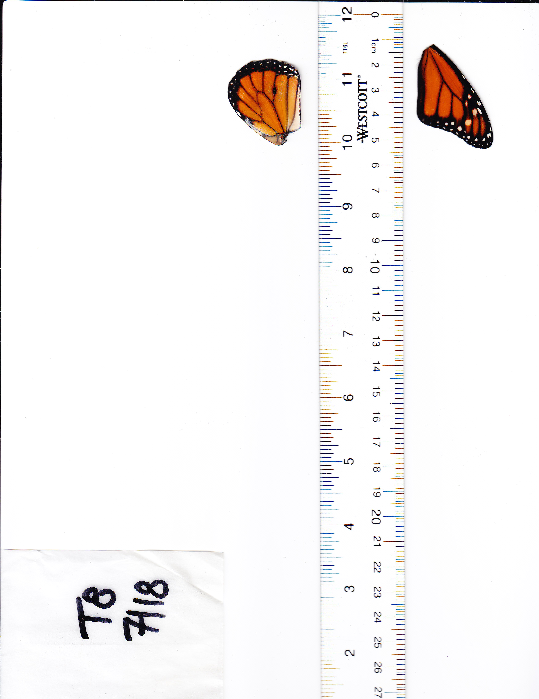

Figure 1: Sample scan of forewing and hindwing. A ruler was placed on the scanning bed for scale.

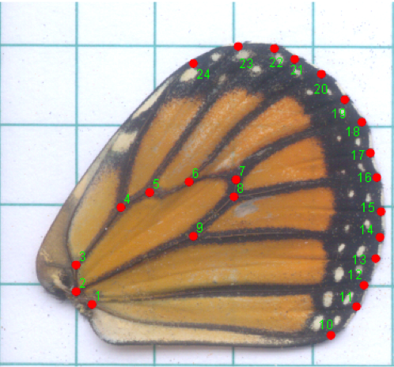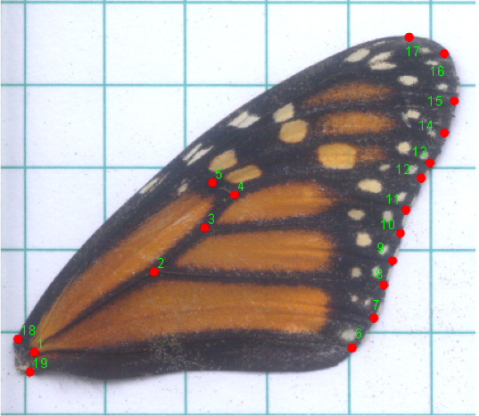

Figure 2b: Landmark digitization of hindwing (taken from Berns 2014). Length was measured from landmark 2 to landmark 18. Width was measured from landmark 24 to landmark 10.

Figure 2a: Landmark Digitization of Forewing (taken from Berns 2014). Length was measured from landmark 1 to landmark 16 while width was measured by finding the longest perpendicular line to the length.

*Data Analysis*

The response variables for the experiment included the lengths and widths of both the forewings and hindwings. Using these measurements, we calculated the fore- and hindwing sizes (area) and shape (aspect ratio). We also calculated area and length asymmetry by subtracting the areas and lengths of the right fore- and hindwings from the left-side counterparts. We conducted a MANOVA test in R (3.3.1) to evaluate the effects of both sex, diet, and any potential interactive effects between sex and diet on all of the response variables.

**III. Results:**

We expected sex to have a significant effect on most morphological characteristics due to inherent sexual dimorphism in the species, so we focused on the effects of diet alone or interactive effects of diet and sex on the seven response variables. As predicted, sex alone had a significant effect on forewing length (F=6.937, p<0.05), forewing area (F=6.781, p<0.05), and hindwing width (F=5.312, p<0.05).

**Aspect Ratio (Fig. 3):** Males reared on *A. incarnata*, on average, had the highest forewing aspect ratio (1.97, SD=0.0657), followed by *A. incarnata* females (1.88, SD=0.1082), *A. curassavica* females (1.86, SD=0.0186), and finally, *A. curassavica* males (1.84, SD=0.1191). Males reared on *A. curassavica* trended toward a significant larger aspect ratio than males reared on *A. incarnata* (F=7.645, p=0.0506); however, neither sex nor diet had significant effects on morphology, individually.

**Asymmetry (Figs. 4 & 5):** Overall, males generally showed more variability in asymmetry than did females in both diet groups (SD=0.177). Males reared on *A. incarnata* showed the highest degree of left-right forewing asymmetry in length (μ= -0.276) and area (μ=-0.404), followed by males raised on *A. curassavica (*μlength = 0.153, μarea = -0.376), females raised on *A. curassavica,* and finally females raised on *A. incarnata*. There were no significant effects of sex or diet on left-right area asymmetry (F=6.074, p=0.790); however, we did see significant interactive effects of sex and diet on left-right length asymmetry (F=6.886, p=0.024). Individually, diet had an almost significant effect on asymmetry, whereas sex had no effect.

**Forewing morphology (Figs. 6-8):** Forewing length was significantly higher in males versus females (F=5.3380, p=0.0379), as was forewing area (F=6.781, p<0.05). Diet had a significant effect on forewing area (F=6.859, p<0.05) and forewing width (F=5.084, p<0.05), but not on length.

**Hindwing Morphology (Figs. 9-11):** Hindwing length and area did not differ significantly between sexes, but hindwing width did vary significantly (F=5.312, p<0.05). Diet alone did not have any significant effect on hindwing area, but we did see significant effects of diet on hindwing length (F=8.448, p<0.05) and hindwing width (F=8.536, p<0.01), as well as significant interactive effects of sex and treatment on hindwing width (F=9.571, p=0.008). See appendix for results figures.

Table 1: Summary of response variable means for male and female monarchs raised on each milkweed diet. “N” refers to the native milkweed diet and “T” refers to the tropical milkweed diet

|  |  |  |  |  |
| --- | --- | --- | --- | --- |
| Sex | Male | Female | Male | Female |
| Treatment | 1. *incarnata* (N) | *A. incarnata* (N) | *A. curassavica* (T) | *A. curassavica* (T) |
| Forewing Area (mm2) | 8.125 | 6.827 | 7.710 | 6.602 |
| Forewing Length (mm) | 4.562 | 4.520 | 4.805 | 4.531 |
| Forewing Width (mm) | 2.316 | 2.402 | 2.582 | 2.471 |
| Hindwing Area (mm2) | 7.579 | 6.480 | 7.454 | 6.602 |
| Hindwing Length (mm) | 3.194 | 3.170 | 3.498 | 3.270 |
| Hindwing Width (mm) | 2.735 | 2.758 | 2.940 | 2.777 |
| Aspect Ratio | 1.970 | 1.885 | 1.861 | 1.840 |
| Length Asymmetry (L-R) | -0.276 | -0.098 | 0.153 | -0.111 |
| Area Asymmetry (L-R) | -0.404 | -0.026 | -0.376 | -0.088 |

Table 2: Summary of MANOVA models examining factors associated with each forewing measurement; *= p<0.05, ** = p<0.01

|  |  |  |  |  |  |
| --- | --- | --- | --- | --- | --- |
| Response Variable | Predictor Variables | df | Mean sq. | F | p |
| Forewing Length | Sex  Diet  Sex x Diet | 1  1  1 | 0.139  0.017  0.300 | 6.937  0.828  1.478 | 0.023*  0.382  0.250 |
| Forewing Width | Sex  Diet  Sex x Diet | 1  1  1 | 0.001  0.092  0.028 | 0.058  5.084  1.531 | 0.813  0.045*  0.242 |
| Forewing Area | Sex  Diet  Sex x Diet | 1  1  1 | 0.635  0.642  0.359 | 6.781  6.859  3.828 | 0.025*  0.024*  0.076 |
| Aspect Ratio | Sex  Diet  Sex x Diet | 1  1  1 | 0.016  0.032  0.005 | 1.678  3.441  0.493 | 0.222  0.091  0.492 |
| Length Asymmetry | Sex  Diet  Sex x Diet | 1  1  1 | 0.001  0.140  0.260 | 0.019  3.705  6.886 | 0.892  0.080  0.024* |
| Area Asymmetry | Sex  Diet  Sex x Diet | 1  1  1 | 0.364  0.004  0.007 | 4.129  0.046  0.074 | 0.067  0.835  0.790 |

Table 3: Summary of MANOVA models examining factors associated with hindwing measurements; *=p<0.05, ** =p<0.01

|  |  |  |  |  |  |
| --- | --- | --- | --- | --- | --- |
| Response Variable | Predictor Variables | df | Mean sq. | F | p |
| Hindwing Length | Sex  Diet  Sex x Diet | 1  1  1 | 0.057  0.127  0.040 | 3.820  8.448  2.684 | 0.073  0.012*  0.125 |
| Hindwing Width | Sex  Diet  Sex x Diet | 1  1  1 | 0.019  0.030  0.337 | 5.312  8.536  9.571 | 0.038*  0.012*  0.009** |
| Hindwing Area | Sex  Diet  Sex x Diet | 1  1  1 | 3.651  0.005  0.059 | 4.649  0.006  0.075 | 0.050  0.938  0.788 |

**IV. Discussion**

The results of this preliminary study showed that only male monarchs experience significant morphological changes in their wings as adults on account of larval diet. Males reared on the non-native diet (*A. curassavica*) had wider forewings and hindwings than males reared on the native diet (*A. incarnata*). While only marginally significant, males reared on *A. curassavica* also trended toward lower aspect ratios and more varied asymmetry than males reared on *A. incarnata*. These results suggest that *A. curassavica* may influence wing size and, subsequently, flight ability of male monarchs*.* Broader hindwings and higher asymmetry are traits that are not consistent with long-distance flight, but rather with evasive maneuvering necessary for males to win territorial disputes and access mates (Jantzen & Eisner 2008). It is possible that the broader hindwings of the males reared on *A. curassavica* might be useful for flight behavior associated more with reproductive success than migration.

Our results indicate that larval diet does impact wing morphology, and we believe this is due to variance in cardenolide concentrations between plants of the *Asclepias* genus. While many studies have shown that sequestration of cardenolides by monarch larvae influences the aposematic coloring of larvae and adult wings (Davis et al. 2014), little work has been done evaluating how plant chemistry impacts wing size and shape. Berns (2014) found that sex affected monarch forewing and hindwing shape, but larval diet – specifically cardenolide content – only impacted forewing shape. This is contrary to our results, which showed the opposite. Both our study and the Berns (2014) study, however, were limited by small sample sizes.

Migratory monarchs generally have longer and narrower forewings, higher aspect ratios (Satterfield & Davis 2014), and a redder hue (Davis et al. 2014) than non-migratory populations. Past research has shown that these traits are directly correlated with gliding ability, and redness specifically has been associated with endurance. This endurance and flight behavior allows for less frequent stops and overall shorter migration time, and implies that those with less red or more truncated wings may be less able to complete migration, migrate slower, or spend more time in stopover sites (Satterfield & Davis 2014). Such reduction in flight ability may lend to the phenomenon of migratory drop out, as in the case of the resident population in Florida and the subpopulation of migratory monarchs dropping out along the Gulf Coast documented by Howard et al. (2010). Morphological analysis can aid in determining the composition of year-round breeding populations, as some of these monarchs could be individuals that dropped out of migration as opposed to non-migratory residents.

Loss of migratory behavior has an array of implications for monarch populations and the communities in which they live and migrate. For monarch populations, loss of migratory behavior has seemingly fostered an increase in infection risk by the specialist protozoan parasite *Ophryocystis elektroscirrha* (OE) (Satterfield et al. 2015). This implies that conservation of migratory behavior is necessary to prevent loss of mechanisms that lower infection prevalence in monarch populations. However, a major knowledge gap that exists is how we can preserve migratory behavior, or prevent migratory dropout. Satterfield et al. (2018) cite supplemental feeding as a potential causal factor of migratory dropout. Unintentional subsidy can provide year-round resources for wildlife, which in turn can alter their behaviors, including migration. If feeding on *A. curassavica* is driving migratory drop-out, is critical we understand the impacts that *A. curassavica* has on monarchs individually to assess what is causing the shift in behavior. Our study attempts to address this issue by gauging the effects of *A. curassavica* on monarch wing morphology, which acts as a predictor of flight performance. If morphology of male monarchs is changing as a result of *A. curassavica* in such a way that disfavors migration, then is it more likely that males are dropping out migration more frequently than females? What does this mean for populations still reaching Mexico? How does this sex ratio impact the resident populations?

Further research is needed to identify the primary drivers of migratory dropout among monarch butterflies. Our results suggest that changes in morphology are affecting male monarchs, but our study is limited to a lab setting. Field-based studies and capture of wild monarchs is needed to assess the magnitude of this morphological shift. However, this is difficult, as the origin of butterflies can be found out, but knowing the diet during development of migratory butterflies that originated elsewhere is virtually impossible. Additionally, there are a variety of other factors that can influence wing morphology and/or flight performance, including OE infection (Bradley & Altizer 2005) and environmental variables such as temperature. Temperature can also impact disease dynamics, and future studies should analyze interactive effects of environmental variables, disease ecology, and morphology and their impact on migratory behavior.

Finally, as expected, the results of our experiment differed between sexes. Monarchs are inherently sexually dimorphic, with males generally having larger and redder wings than females, while females generally have more mass allocated to the abdominal region. This is due to difference in life histories, and the allocation of energy to reproductive processes (Berns 2014). The fact that we saw no significant morphological differences in female monarchs between diet treatments while there were significant differences in males is an interesting discovery that warrants further investigation. Our study had a very small sample size, so in the future, this experiment could be replicated with a larger sample size to validate sex-specific trends in morphology. This experiment did not evaluate any traits or behaviors outside of morphology, so while we did not see differences in morphology due to diet treatment in female monarchs, it is still possible that there are other effects on female behavior or reproductive capacity.

**VI. Conclusion**

If migration is an endangered behavior, it is critical that we understand the mechanisms driving migratory dropout and the implications for communities on a global scale and across taxa. Especially in the context of climate change, where biodiversity as a whole is threatened, it is necessary to know other factors that could be endangering wildlife, and the processes driving that threat. Climate change has the capacity to alter disease dynamics and resource ability, which can and will affect all species, migratory or otherwise. However, a shift toward sedentary behavior also can affect resource distribution, species interactions, and population dynamics that could negatively impact fitness of many species. This study contributes to a growing body of literature demonstrating a trans-taxa shift in movement patterns in response to human activity. Understanding the these shifts can help with implementation of conservation initiatives and for wildlife and for mitigating threats to wildlife and human health in environments where sedentary behavior is becoming more common.

**Works Cited:**

Agrawal AA, Petschenka G, Bingham RA, Weber MG, Rasmann S. 2012. Toxic cardenolides: chemical ecology and coevolution of specialized plant–herbivore interactions. *New Phytol.* 194(1):28–45

Altizer S, Davis AK. 2010. Populations of monarch butterflies with different migratory behaviors show divergence in wing morphology. *Evol. Int. J. Org. Evol.* 64(4):1018–28

Altizer SM, Oberhauser KS. 1999. Effects of the protozoan parasite Ophryocystis elektroscirrha on the fitness of monarch butterflies (Danaus plexippus). *J. Invertebr. Pathol.* 74(1):76–88

Batalden R V, Oberhauser KS. 2015. Potential changes in eastern North American monarch migration in response to an introduced milkweed, Asclepias curassavica. *Monarch. a Chang. world Biol. Conserv. an iconic butterfly*. 215–24

Berns A. 2014. A geometric morphometric analysis of wing shape variation in monarch butterflies Danaus plexippus

Bradley CA, Altizer S. 2005. Parasites hinder monarch butterfly flight: implications for disease spread in migratory hosts. *Ecol. Lett.* 8(3):290–300

De Roode JC, Pedersen AB, Hunter MD, Altizer S. 2008. Host plant species affects virulence in monarch butterfly parasites. *J. Anim. Ecol.* 77(1):120–26

Gowler CD, Leon KE, Hunter MD, de Roode JC. 2015. Secondary defense chemicals in milkweed reduce parasite infection in monarch butterflies, Danaus plexippus. *J. Chem. Ecol.* 41(6):520–23

Jantzen B, Eisner T. 2008. Hindwings are unnecessary for flight but essential for execution of normal evasive flight in Lepidoptera. *Proc. Natl. Acad. Sci.*

Johnson H, Solensky MJ, Satterfield DA, Davis AK. 2014. Does skipping a meal matter to a butterfly’s appearance? Effects of larval food stress on wing morphology and color in monarch butterflies. *PLoS One*. 9(4):e93492

Lindsey E, Altizer S. 2009. Sex differences in immune defenses and response to parasitism in monarch butterflies. *Evol. Ecol.* 23(4):607–20

Ricklefs RE, Miles DB. 1994. Ecological and evolutionary inferences from morphology: an ecological perspective. *Ecol. Morphol. Integr. Org. Biol.* 1:13–41

Satterfield DA, Davis AK. 2014. Variation in wing characteristics of monarch butterflies during migration: Earlier migrants have redder and more elongated wings. *Anim. Migr.* 2(1):

Satterfield DA, Maerz JC, Altizer S. 2015. Loss of migratory behaviour increases infection risk for a butterfly host. *Proc. R. Soc. London B Biol. Sci.* 282(1801):20141734

Satterfield DA, Marra PP, Sillett TS, Altizer S. 2018. Responses of migratory species and their pathogens to supplemental feeding. *Phil. Trans. R. Soc. B*. 373(1745):20170094

Via S, Lande R. 1985. Genotype‐environment interaction and the evolution of phenotypic plasticity. *Evolution (N. Y).* 39(3):505–22

**Appendix A:**

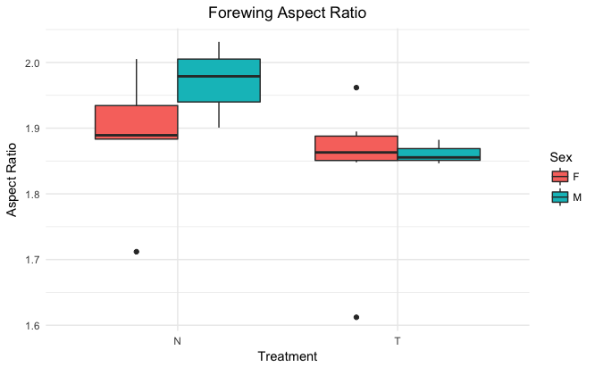

Figure 3: Comparison of forewing aspect ratio means by sex (M and F) and treatment (N and T)

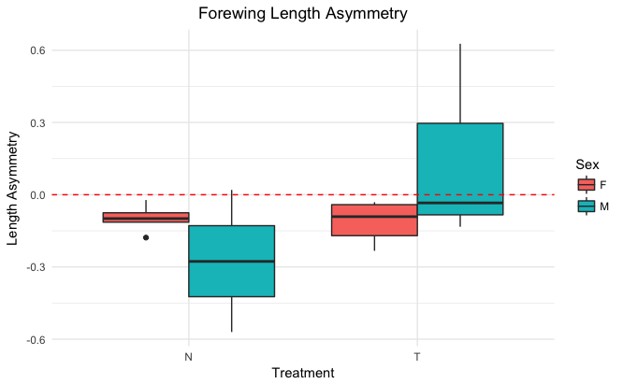

Figure 4: Comparison of forewing length asymmetry means by sex (M and F) and treatment (N and T)

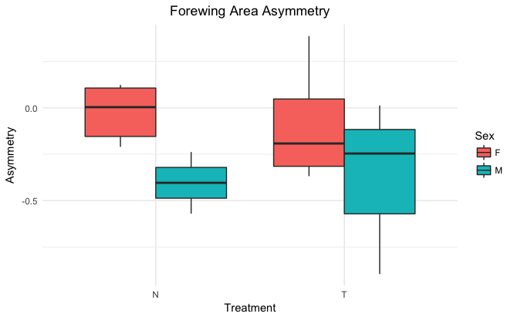

Figure 5: Comparison of forewing area asymmetry means by sex (M and F) and treatment (N and T)

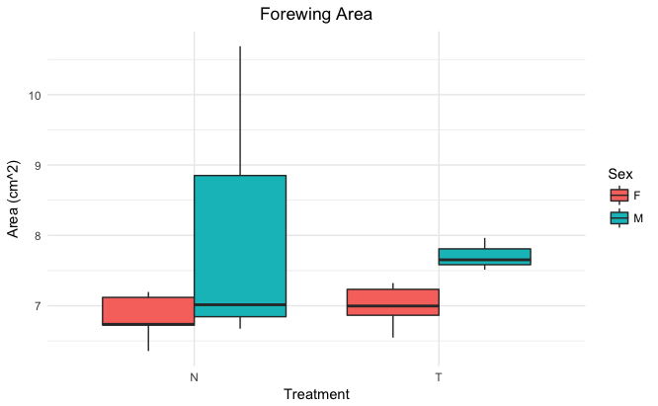

Figure 6: Comparison of forewing area asymmetry means by sex (M and F) and treatment (N and T)

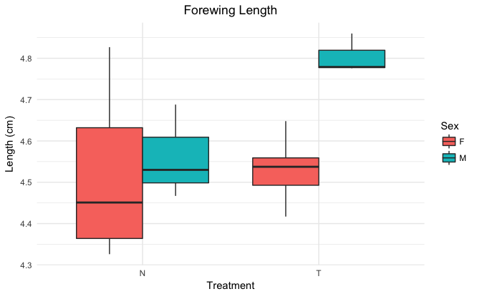

Figure 7: Comparison of forewing length means by sex (M and F) and treatment (N and T)

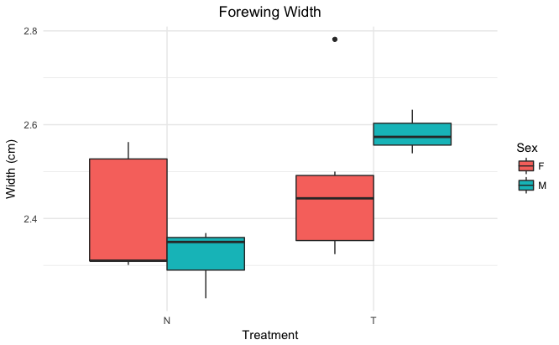

Figure 8: Comparison of forewing width means by sex (M and F) and treatment (N and T)

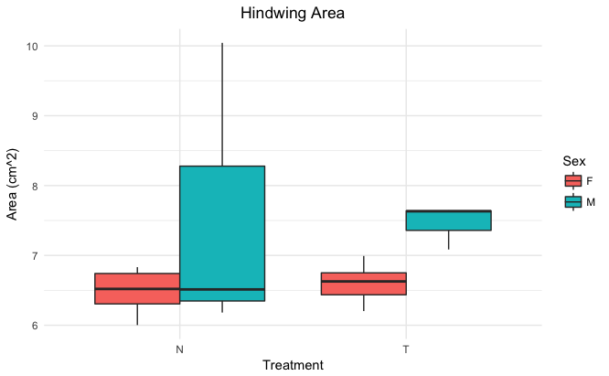

Figure 9: Comparison of hindwing area means by sex (M and F) and treatment (N and T)

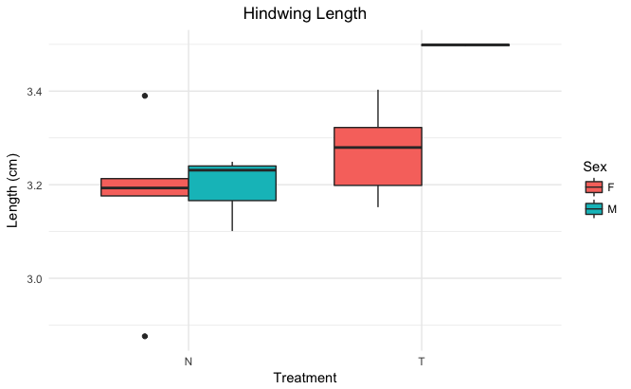

Figure 10: Comparison of hindwing length means by sex (M and F) and treatment (N and T)

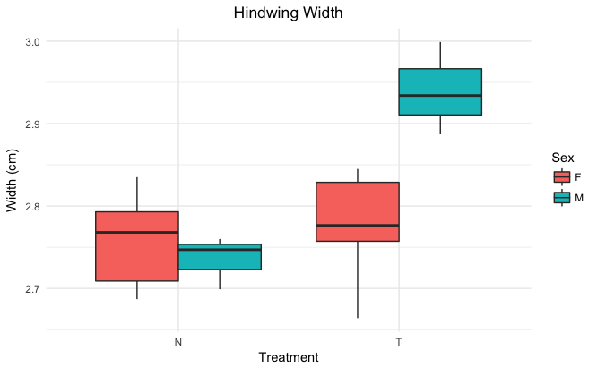

Figure 11: Comparison of hindwing width means by sex (M and F) and treatment (N and T)